1. Displays all available shells

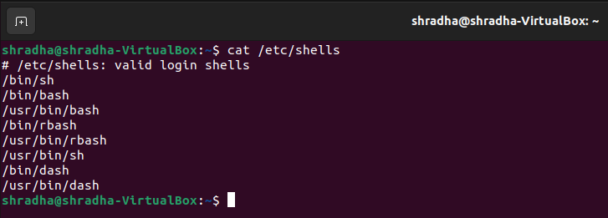

1. To keep track of every registered user that has access to a system.

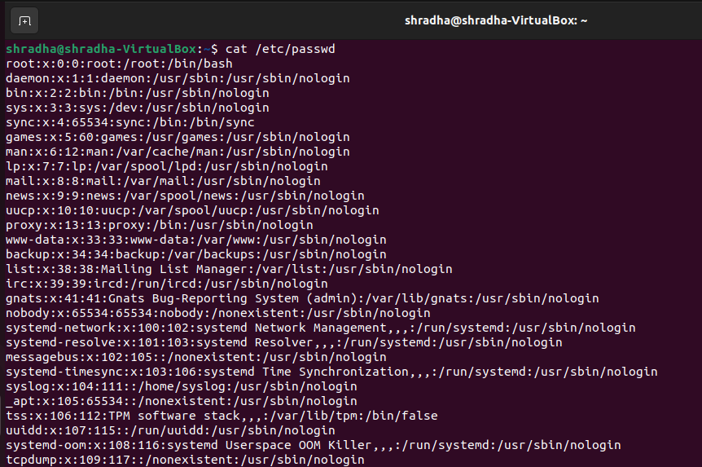

1. Use of Date command to see the date, also use of who and date command simultaneously and fetch this data in a file and use more command to see that data.

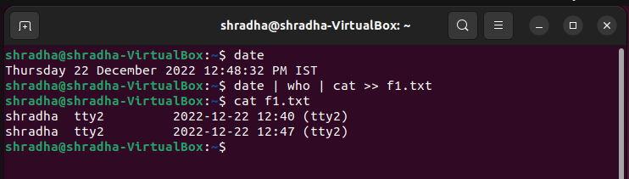

1. Use of sed command to swap one word with another in each line of a file.

